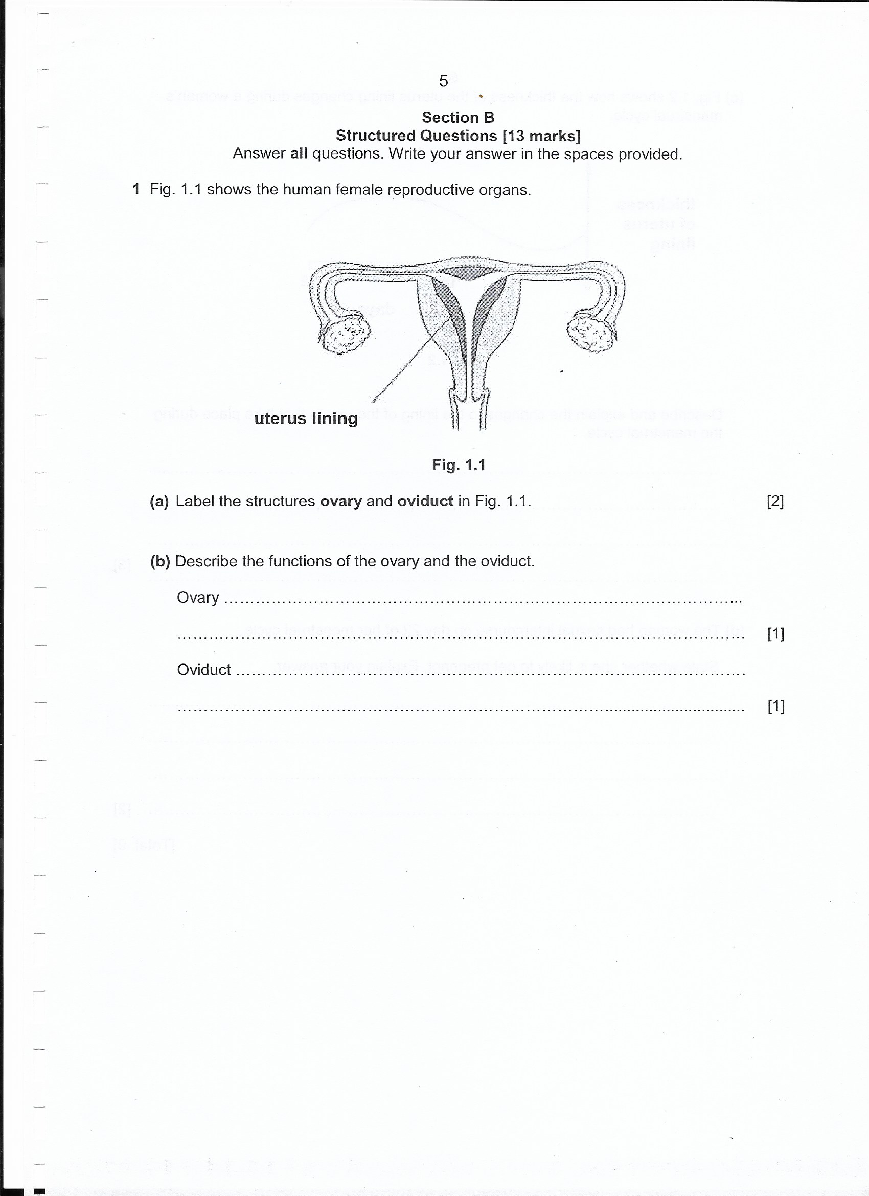

1. State the functions of each of the following [2]

Uterus lining:

Oviduct:

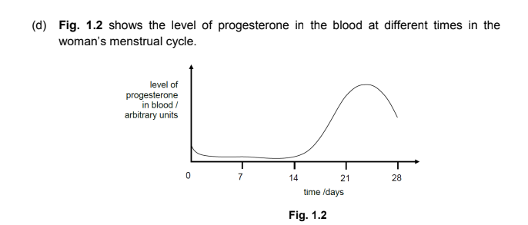

Using the information in **Fig 1.2**, suggest and explain a time range during the menstruation cycle when implantation will likely be successful. [3]